A12 – Offline Security Tools

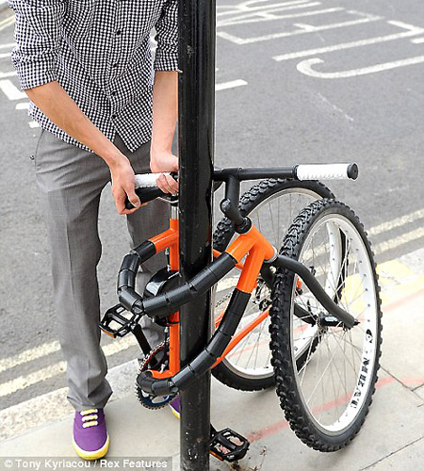
- Cable Lock

Security Purpose:
A cable lock is used to physically secure items like laptops or bicycles to prevent theft.
Limitation:
It can be cut using tools, so it is not completely secure.

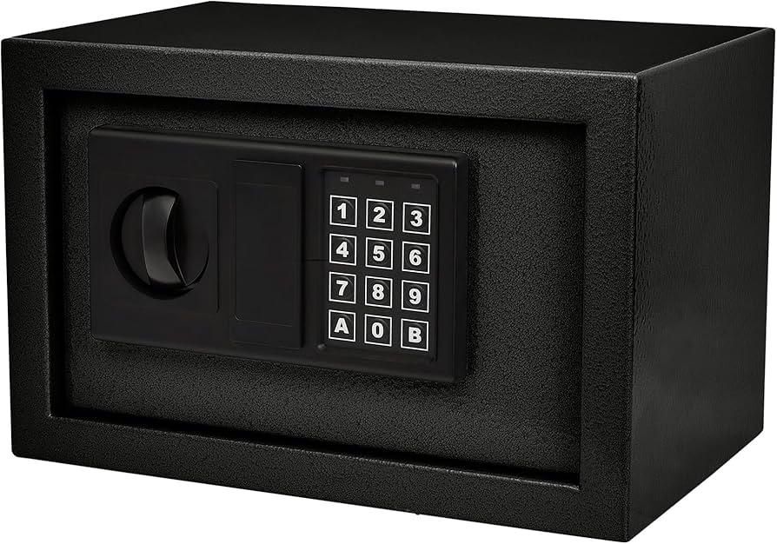
- Safe

Security Purpose:
A safe is used to store valuables securely, protecting them from theft or unauthorized access.
Limitation:
If the password is known or the safe is forced open, security can be compromised.

- Paper Shredder
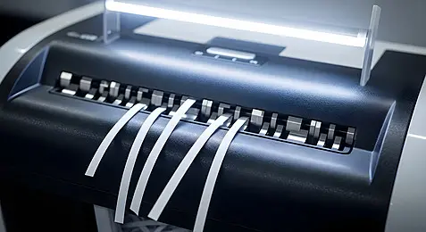

Security Purpose:
A shredder destroys sensitive documents to prevent information theft.
Limitation:
Some shredders produce strips that can be reconstructed.

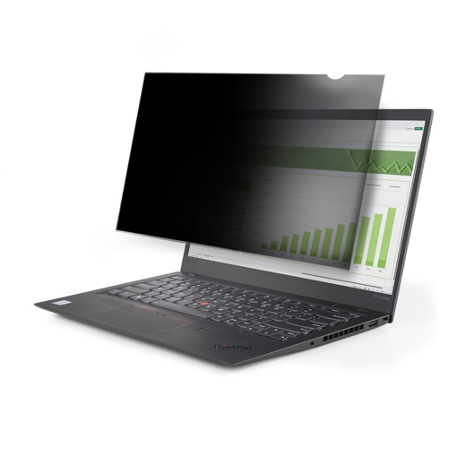
- Privacy Screen (Laptop / Phone)

Security Purpose:
A privacy screen limits viewing angles so others cannot see the screen content.
Limitation:
Does not prevent digital hacking, only visual privacy.

- RFID Blocking Wallet
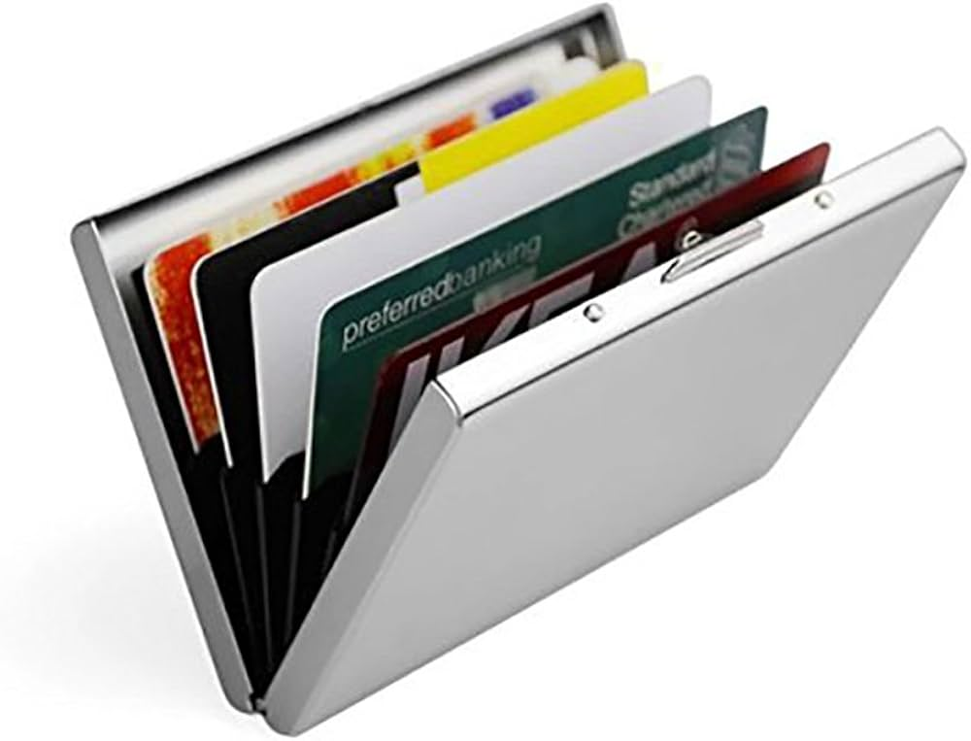

Security Purpose:
An RFID wallet blocks signals to protect cards from unauthorized scanning.
Limitation:
Only protects RFID cards, not other types of attacks like phishing.

